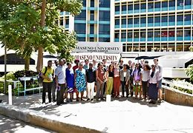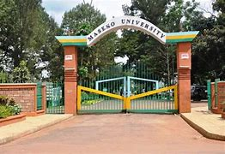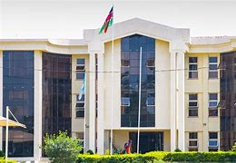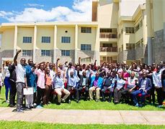 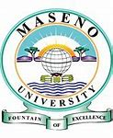

In October 1990, Maseno Government Training Institute was merged with Siriba Teacher’s Training College to form Maseno University College as a constituent college of [Moi University](https://en.wikipedia.org/wiki/Moi_University" \o "Moi University). It became a full fledged university 11 years later in 2001. It is an accredited university, enacted by an Act of Parliament in 1991.

**Feel at Home**

**Additional Information:**The university has 12 schools and an institute offering various degrees, diplomas and certificates. The eCampus, the first of its kind in Kenya, is a virtual campus that runs flexible online programmes both for on-campus students as well as off-campus students enrolled in various Maseno University programmes through eLearning.

*Please for more info*  **:** [Maseno University - Fountain of excellence](https://maseno.ac.ke/)

Located in Kisumu along Kisumu-Busia Road

**Maseno University** is a public [university](https://en.wikipedia.org/wiki/University) based in the [Maseno](https://en.wikipedia.org/wiki/Maseno) district of the [Kisumu County](https://en.wikipedia.org/wiki/Kisumu_County), Kenya, along the [Equator](https://en.wikipedia.org/wiki/Equator).[[1]](https://en.wikipedia.org/wiki/Maseno_University#cite_note-1) It was fully fledged as a university in 2001, after being a constituent college of [Moi University](https://en.wikipedia.org/wiki/Moi_University" \o "Moi University) for a decade. It has over 10,000 students pursuing programmes offered in the university campuses and it is currently ranked among the best universities in Kenya.

*Maseno University Exceptional school*